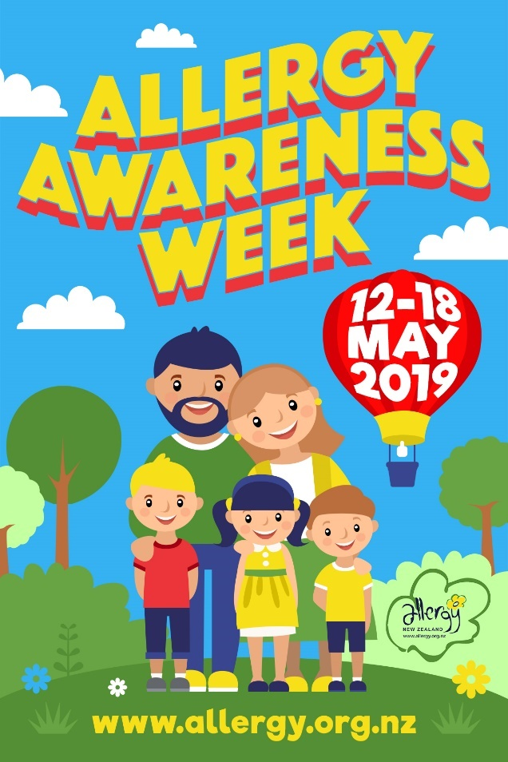

ALLERGY AWARENESS WEEK 2019
Links to resources identified in the Teacher Resource Pack:

Pre-school Activities
- The Wiggles “Ooey Ooey Ooey Ooey Allergies” Song

Primary School Activities
- The Wiggles “Ooey Ooey Ooey Ooey Allergies” Song
- Suzy’s World ‘What is an allergy?’ video (includes quiz and cloze passage)
- Allergy Kahoot - a fun online group quiz for older primary school students
- Glitter Paint experiment: Understanding Cross Contamination Lesson Plan (Lesson 3: Resource Pack)

Intermediate School Activities
- Understanding Cross Contamination Lesson Plan (Lesson 3: Resource Pack) lesson plan and video - great for students participating in Garden to Table program or food technology classes
- How to Avoid Cross Contamination Video
- Allergy Kahoot

Additional Resources for Teachers Links:
- Allergy and Anaphylaxis Guidelines for Schools
- ASCIA anaphylaxis e-training module for schools and early childhood education
- Preparing for camp and overnight school trips with food allergies
- Risk minimisation strategies for schools and pre-schools
- 250K resources (developed by the Australian National Allergy Strategy)
- Primary School
- Secondary school
- ASCIA Allergy and Anaphylaxis Action Plans
- Thai Series Books for Children with Food Allergy – Thai’s New Friend at Kindy and Thai’s First Week at School available from www.myfoodallergyfriends.com

